Stash Changes

What is Stash Changes?
# Source: AI Source: Provided by: [Data Path: Persons Table -> ID Column: 1, Name_En Column: Motasem Essam] -> From: [ChatGPT] on [2/15/2026]
Stashing changes in Git is a way to temporarily save uncommitted changes without committing them to the branch, so you can switch branches or work on something else safely.
Think of it as putting your current work on a “shelf” to come back to later.

Key points
# Source: AI Source: Provided by: [Data Path: Persons Table -> ID Column: 1, Name_En Column: Motasem Essam] -> From: [ChatGPT] on [2/15/2026]
- Purpose:
  - You are working on something but need to switch branches or pull updates without committing incomplete work.
- Stored temporarily:
  - Changes are stored in a stack called the stash.
  - You can apply or pop them back when ready.
- Works for:
  - Modified files
  - Staged files
  - Sometimes untracked files (with option)

Common Commands
# Source: AI Source: Provided by: [Data Path: Persons Table -> ID Column: 1, Name_En Column: Motasem Essam] -> From: [ChatGPT] on [2/15/2026]
1. Stash changes
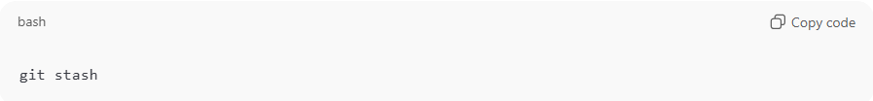
git stash
- Saves all tracked modifications and cleans working directory.
2. List stashes
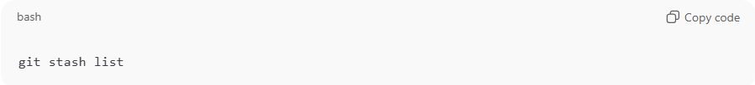
git stash list
- Shows all stashed changes, e.g., stash@{0}: WIP on feature-login
3. Apply stash
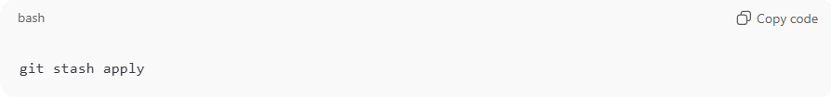
git stash apply
- Applies the latest stash without removing it from the stash list
4. Pop stash
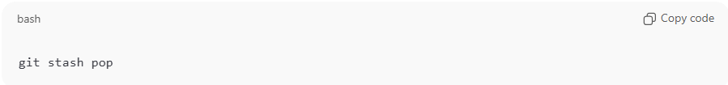
git stash pop
- Applies the latest stash and removes it from the list
5. Stash with message
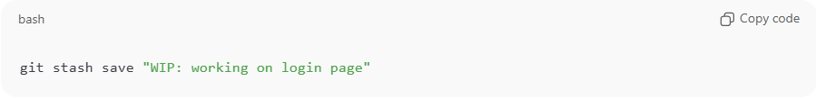
git stash save "WIP: working on login page"
6. Stash untracked files
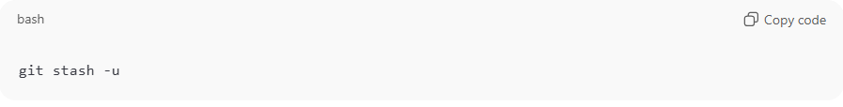
git stash -u

Example Workflow
# Source: AI Source: Provided by: [Data Path: Persons Table -> ID Column: 1, Name_En Column: Motasem Essam] -> From: [ChatGPT] on [2/15/2026]
- You are working on a feature branch:
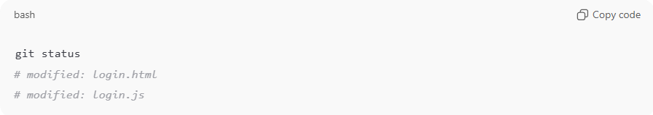
git status
# modified: login.html
# modified: login.js
- You need to switch to main to fix a bug:
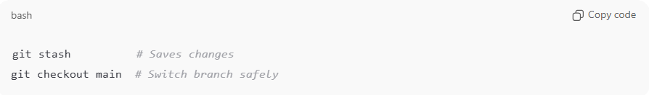
git stash # Saves changes
git checkout main # Switch branch safely
- After fixing the bug, go back to your branch:
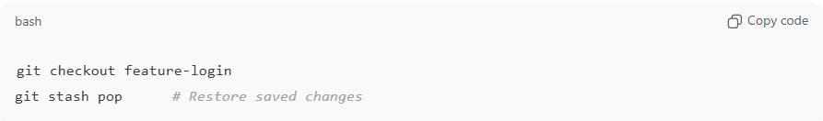
git checkout feature-login
git stash pop # Restore saved changes

Benefits of Stash
# Source: AI Source: Provided by: [Data Path: Persons Table -> ID Column: 1, Name_En Column: Motasem Essam] -> From: [ChatGPT] on [2/15/2026]
- Temporarily saves uncommitted work
- Allows safe branch switching
- Keeps working directory clean
- Useful for emergency fixes on other branches

💡 Memory trick:
# Source: AI Source: Provided by: [Data Path: Persons Table -> ID Column: 1, Name_En Column: Motasem Essam] -> From: [ChatGPT] on [2/15/2026]
Stash = put your work on a temporary shelf → switch branches → come back and take it off the shelf ✅

